Threats to Privacy in a Digital Age
Yuanze Huang
Sydney university

Threats to Privacy in Digital Age
Technology keeps on evolving and we are becoming highly dependent on technology these days. Transforming processes digitally makes them more effective and efficient (Samuels, 2022). Almost everything and every process are now being digitalized. We share our private information on these digital technologies without knowing the implications they can have on us. This has led to creating various threats to privacy of peope in the digital world. We will understand the impact that digitalization has been making in our lives to evaluate many threats that come along with the benefits offered by digital technology and these threats will be explained to examine their impact on privacy of people. Due to digitalization, the biggest threat is imposed on our privacy. There are many ways in which the use of these technologies is exposing our private information and this information is also being used by hackers and malicious actors to harm us. These threats will be explained in the blog using examples from case studies that show how the privacy of users has been compromised.

Digitalization is a threat to privacy
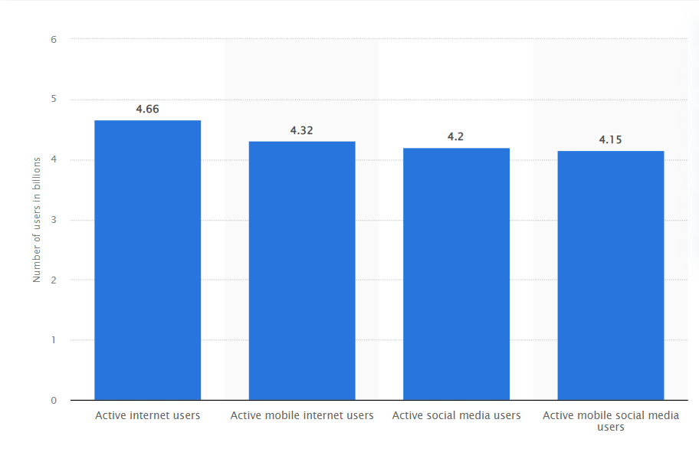
Figure 1: Global internet users
Source: (Johnson, 2021)
In today’s world, almost everything is digitalizing. Advancements are being made in technology constantly and almost everyone in the world uses technology in one way or another. With the increase in technology, cyberattacks are also increasing rapidly. As per a report by Johnson (2021), 4.66 billion people were found to be users of the internet which accounts for 59.5% of the world’s population. Several devices and applications use our data such as the Internet of Things, social media, businesses, and many others. Digitalization offers many benefits but along with these, it lays a huge impact on our privacy. In the digital age, the data is stored on online channels and it can be accessed easily with a click of a button. However, the digitalization of data and storing this data online causes many challenges. For example, I have seen many cases where people complained about how their private information leaked because of the use of digital technologies. The following threats can be sustained due to the use of digital technology.

Threats to privacy due to the use of IoT devices
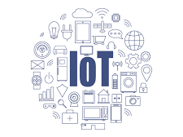
Figure 2: Internet of Things
Source: (NJCCIC, 2020)
Because of the storage of data online, it is not as secure as it used to be. One of the most popular devices that are used by people and that collects their data is the internet of things or IoT. The reliance of people on IoT devices is constantly increasing due to which the amount of data shared over online channels is also growing rapidly. The biggest concern that arises due to this is related to our privacy. IoT devices such as mobile applications, fitness trackers, Wi-Fi connected devices, and others collect our information in various ways and every time we share information through these devices the security of our information is compromised. The use of IoT devices exposes users to many types of threats related to privacy (Hwang, 2015). We share our private information online in many different ways, without even realizing it. All the private information we share over the internet can be easily read by cybercriminals and it can be used by them to harm us. Many threats relating to our privacy have emerged due to digitalization. Identity theft is one of the threats concerned with the use of the Internet. Under this information such as Personal Identifiable Information (PII) and Personal Health Information (PHI) can be retrieved by hackers and unfair advantages can be taken by them using our identity. A survey by the Australian Institute of Criminology (AIC) found that about 1 in every 4 Australians face identity crime at least once in their lives (GOV, 2022a).
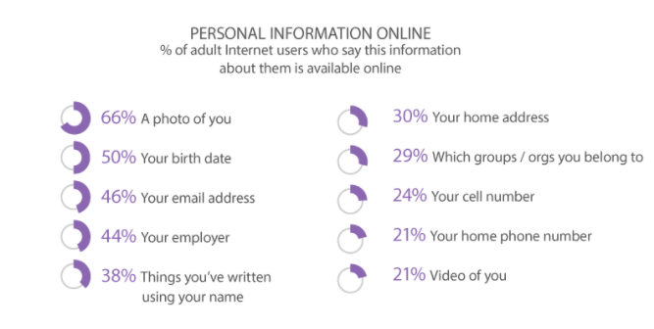
Figure 3: Personal information shared online
Source: (Okwe, 2017)
A recent case where the use of a mobile application led to a data breach is related to LinkedIn. In 2021, data of about 700 million LinkedIn users were extracted by hackers using data scraping techniques, and the PII of users relating to phone numbers, names, location, addresses, and others was exposed online (Morris, 2021). The data so exposed gave malicious actors information about plenty of users which could be further used by them to plan attacks on the users.

Threats to privacy due to the use of Social Networks
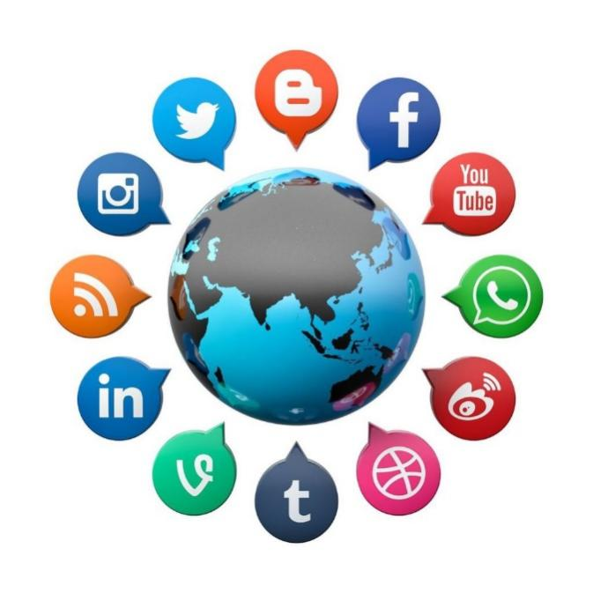
Figure 4: Social Networking Sites
Source: (Asmamehmoodbutt, 2022)
With the growing popularity of social networks, the amount of personal data being shared is increasing rapidly. Due to this, privacy threats are also growing at full tilt. There are many cases in which private information of users is leaked due to their availability over social media. One of those is the case of Facebook and Cambridge Analytica. In the year 2018, a scandal between Facebook and Cambridge Analytica was disclosed under which data of about 87 million Facebook users were exposed to Cambridge Analytica through an app called "This Is Your Digital Life". Data such as name, birthdate, phone numbers, and others were extracted through this app. This data was used to support Donald Trump in the presidential elections of 2016 (Granville, 2018).
Another social networking channel called CAM4, an adult video streaming website faced a data breach in March 2020 where data relating to 10.88 billion records was exposed (Rundle, 2021). The exposed data included information relating to names, addresses, chats, sexual orientation, payment details, and many others. Most of this data was linked to cloud storage which can be used by hackers for many years to blackmail and defame the information owners (Rundle, 2021).
Many programs and security options have been created to protect the privacy of the users but since all the data shared is decentralized and can be accessed by anyone, many loopholes exist in the system using which cyber criminals take advantage of our private information. Our personal information including our photo, birth date, email address, home address, and many more can now be easily accessed by malicious actors due to digitization. Almost all companies connect with their customers using online channels (Styvén & Wallström, 2019). The data shared by their customers is stored by most of them on the internet using services such as the cloud. From consumer goods to banks to hospitals, every industry is shifting towards digitization vigorously. Due to this, the Personal Identifiable Information and the Personal Health Information of the users are now available on online channels. These channels give easy access to the information to cybercriminals, which they can use for unethical purposes.

Threats occurred in financial institutions and Hospitals related to privacy
Many important processes such as banking and healthcare are also being managed using the internet and these institutions use digital technology to store our valuable personal information such as bank account details and health-related data on online channels. This information can be retrieved by malicious actors easily and any leak of such information can affect us extensively. Our bank account details can be accessed by hackers and it can lead to financial losses (Bouveret, 2018). Hackers can also use your name to apply for loans by using your name, birthdate, and social security number.
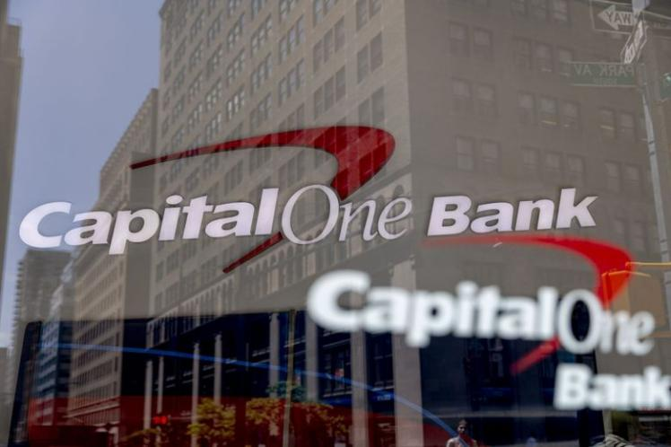
Figure 5: Capital One Bank
Source: (Seattle Times, 2021).
Cases, where the personal information of users was compromised, have been seen in a financial institutions. One such case that occurred in 2019 showed that Capital One, a financial institution fell prone to a data leak when a software engineer, Paige A. Thompson who formerly worked for Amazon Web Services, accessed one of the AWS servers that consisted of data relating to 100 million credit card applications (Seattle Times, 2021). It impacted 6 million people in Canada and 100 million people in the United States. The data included social security numbers, bank account details, and Social Insurance numbers. Customers filed a lawsuit against the company because of this data leak and Capital One had to pay $190 million to settle it (Seattle Times, 2021). This shows that with the growth of the digital age, the concept of true privacy has ceased to exist and our data is not at all safe anymore.

Figure 6: Melbourne Heart Group Logo
Source: (Melbourne Heart Group, 2022)
A case relating to a health care association also happened in Australia where privacy was breached. In February 2019, a health association called Melbourne Heart Group of Australia also faced the consequences of a data breach when information related to 15000 of their patients was leaked due to some ransomware attack. Personal details and medical data of patients were compromised due to this attack and exposed them to potential identity thefts and phishing attacks (Martin, 2019).

Threats related to Location Tracking
Location tracking is another threat that occurs due to digitization (Li & Zhu, 2016). Many applications that we use ask us to turn on location and by doing this our location information is made available to the world. The location information provided can be used to track us which is very dangerous and insecure. Stalking is also one way in which our privacy can be compromised.
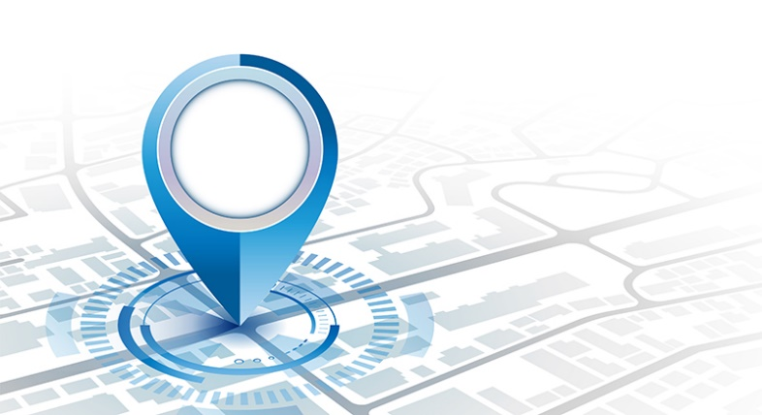
Figure 7: Location Tracking
Source: (Montalbano, 2021)
When using social media, users post personal information such as photographs, location, videos, etc. These can be intercepted by the preparators and they can use them for blackmailing, defamation, and other immoral acts. The threats above discussed only give a brief view of how our privacy is affected because of digitization. With access to the PII of the users, hackers can also use our personal information to cause fraud for financial gains (Tao et al., 2019). Along with these, many other threats are concerned with the privacy of the users because of the use of digital technologies.

Policies made to protect privacy

Figure 8: Office of Australian Information Commissioner
Source: (OAIC, 2022).
Due to the increase in threats relating to privacy, privacy policies have been implemented and many ways have been advised to avoid compromise of Personal Information. To protect your private information, it is advised that you must read the privacy policies of the IoT devices used and the privacy settings offered by those devices must also be used. When disposing of the device, all of your details must be deleted. Social media networks offer privacy-related settings which must be used as it secures your details to a certain extent (OAIC, 2022). In cases where your private information is misused, social media complaints can be made. Businesses must make sure that they are using secure websites to handle the private information of their customers. Up-to-date security software should be installed by them to ensure the security of the user’s information. If cyberattacks occur, companies must quickly take proper action towards them and make policies to avoid these attacks in the future. The government also offers policies and regulations relating to privacy. One such act is The Privacy Act 1988. It is an act implemented by the legislation of Australia, that provides rules and policies related to the online privacy of users (GOV, 2022b). This Act explains the rights of users in the context of their privacy and the legal implications that can occur in case of breach of privacy.

Conclusion
It can be concluded that the Digitalization of processes is constantly increasing and almost everyone is using digital technology. Many benefits are offered by these technologies but it also consists of many risks. Our privacy is being exposed in many ways and it is a threat to us. IoT devices, social media, businesses, etc. are all collecting our private information and this information can be accessed by malicious actors to harm us. There are many cases where the private information of users has been leaked because of the use of digital technology. We must use these technologies with care and we must be aware of how they can harm us. Ways devised to protect user privacy should be used by us to avoid the negative impacts of technology use to enjoy the benefits offered by them effectively.

References
Asmamehmoodbutt. (2020). Social Networking Sites And Social Relations. Medium. Retrieved 7 April 2022, from https://medium.com/@asmamehmoodbutt/social-networking-sites-and-social-relations-a15a64ba1545.
Bouveret, A. (2018). Cyber risk for the financial sector: A framework for quantitative assessment. International Monetary Fund.
GOV. (2022a). Privacy. ag.gov. Retrieved 7 April 2022, from https://www.ag.gov.au/rights-and-protections/privacy.
GOV. (2022b). Privacy. ag.gov. Retrieved 7 April 2022, from https://www.ag.gov.au/rights-and-protections/privacy.
Granville, K. (2018). Cambridge Analytica and Facebook: The Scandal and the Fallout So Far (Published 2018). Nytimes.com. Retrieved 7 April 2022, from https://www.nytimes.com/2018/04/04/us/politics/cambridge-analytica-scandal-fallout.html.
Hwang, Y. (2015). IoT Security &amp; Privacy. Proceedings Of The 1St ACM Workshop On Iot Privacy, Trust, And Security. https://doi.org/10.1145/2732209.2732216
Johnson, J. (2021). Internet users in the world 2021 | Statista. Statista. Retrieved 7 April 2022, from https://www.statista.com/statistics/617136/digital-population-worldwide/.
Li, Y., & Zhu, T. (2016). Gait-based wi-fi signatures for privacy-preserving. In Proceedings of the 11th ACM on asia conference on computer and communications security (pp. 571-582).
Martin, L. (2019). Hackers 'scramble' patient files in Melbourne heart clinic cyber attack. the Guardian. Retrieved 7 April 2022, from https://www.theguardian.com/technology/2019/feb/21/hackers-scramble-patient-files-in-melbourne-heart-clinic-cyber-attack.
Melbourne Heart Group. (2022). Cardiologist Melbourne, Victoria, Tasmania | MELBOURNE HEART GROUP. Melbourneheart.com.au. Retrieved 7 April 2022, from https://www.melbourneheart.com.au/.
Montalbano, E. (2021). Apple’s Device Location-Tracking System Could Expose User Identities. Threatpost.com. Retrieved 7 April 2022, from https://threatpost.com/apples-location-system-expose-identities/164615/.
Morris, C. (2021). LinkedIn data theft exposes personal information of 700 million people. Fortune. Retrieved 7 April 2022, from https://fortune.com/2021/06/30/linkedin-data-theft-700-million-users-personal-information-cybersecurity/.
NJCCIC. (2020). IoT Device Security and Privacy. Cyber.nj.gov. Retrieved 7 April 2022, from https://www.cyber.nj.gov/informational-report/iot-device-security-and-privacy.
OAIC. (2022). Online safety. oaic.gov. Retrieved 7 April 2022, from https://www.oaic.gov.au/privacy/your-privacy-rights/social-media-and-online-privacy/online-safety.
Okwe, C. (2017). How the Digital Age is Impacting Our Personal Privacy. Medium. Retrieved 7 April 2022, from https://medium.com/@cre8tivemediaservices/how-the-digital-age-is-impacting-our-personal-privacy-695326dd1455.
Rundle, J. (2021). Company Data Hoards Create Tempting Targets for Hackers. WSJ. Retrieved 7 April 2022, from https://www.wsj.com/articles/company-data-hoards-create-tempting-targets-for-hackers-11629711000.
Samuels, M. (2022). ​What is digital transformation? Everything you need to know about how technology is reshaping business | ZDNet. ZDNet. Retrieved 7 April 2022, from https://www.zdnet.com/article/what-is-digital-transformation-everything-you-need-to-know-about-how-technology-is-reshaping/.
Seattle Times. (2021). Capital One to pay $190M settlement in data breach linked to Seattle woman. seattletimes.com. Retrieved 7 April 2022, from https://www.seattletimes.com/business/capital-one-to-pay-190m-settlement-in-data-breach-linked-to-seattle-woman/.
Styvén, M. E., & Wallström, Å. (2019). Benefits and barriers for the use of digital channels among small tourism companies. Scandinavian Journal of Hospitality and Tourism, 19(1), 27-46.
Tao, H., Bhuiyan, M. Z. A., Rahman, M. A., Wang, G., Wang, T., Ahmed, M. M., & Li, J. (2019). Economic perspective analysis of protecting big data security and privacy. Future Generation Computer Systems, 98, 660-671.

